Predicting Flight Delays in Commercial Aviation
Mario Alonso López
Aerospace Engineer, Data Science enthusiast

E-mail: m.alonso.lopez123@gmail.com
LinkedIn : https://www.linkedin.com/in/marioalonsolopez/

Published : dd/mm/yyyy
Abstract
Airborne transportation is widely accepted as a cornerstone in mobility worldwide. Its meaningful impact on the global society is remarkable from a social and economic viewpoint. Societies all across the globe greatly benefit from this industrial activity. However, in order to do so, flight tickets must be fair. Considering the various costs airlines have to face, margins are somewhat tight-fitting; so, in order to make it possible for air travellers to fly at a reasonable price, air carriers require minimizing operational costs. There are several challenging tasks an operator has to tackle to maximize its profit, such as minimizing maintenance activities or optimizing fuel consumption upon route planning. Among all these tasks, this project will focus on predicting flights delays. According to the Federal Aviation Administration (FAA), the total cost of delays from 2016 to 2019 has steadily increased from $23.7 to $33 billion ($5.6 to $8.3 billion corresponding to air carriers) ^{[1]}. By addressing the punctuality issue, operators can better understand what the main reasons are behind delays, and set up corrective measures accordingly in advance. Since meteorological predictions are quite accurate nowadays, the proposed model takes this valuable data into consideration in order to generate actionable insights. A comprehensive analysis is undertaken considering various predictors besides weather data. In this paper I apply predictive modelling approaches based on machine learning techniques using publicly available flight and meteorology datasets from the US for year 2019. A binary classifier is built on such data, achieving a Precision-Recall area under the curve (PR-AUC) of 0.XX over the entire dataset.

Keywords: flight delay, binary classifier, PR-AUC

1. Introduction
This paper is mainly based on two datasets retrieved from two main sources, both originating on US data for year 2019:

- On-Time Performance (OTP) ^{[2]}, provided by the US Bureau of Transportation Statistics (BTS)
- Local Climatological Data (LCD) ^{[3]}, provided by the US National Oceanic and Atmospheric Administration
A brief summary of Airline Service Quality Performance is provided below (year 2019) ^{[4]}.

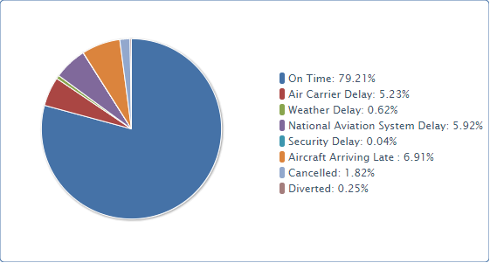
Figure 1. On-Time Arrival Performance National (January - December, 2019)
There are five categories of delays defined by the BTS ^{[5]}:
- Air Carrier: The cause of the cancellation or delay was due to circumstances within the airline's control (e.g. maintenance or crew problems, aircraft cleaning, baggage loading, fueling, etc.).
- Extreme Weather: Significant meteorological conditions (actual or forecasted) that, in the judgment of the carrier, delays or prevents the operation of a flight such as tornado, blizzard or hurricane.
- National Aviation System (NAS): Delays and cancellations attributable to the national aviation system that refer to a broad set of conditions, such as non-extreme weather conditions, airport operations, heavy traffic volume, and air traffic control.
- Late-arriving aircraft: A previous flight with same aircraft arrived late, causing the present flight to depart late.
- Security: Delays or cancellations caused by evacuation of a terminal or concourse, re-boarding of aircraft because of security breach, inoperative screening equipment and/or long lines in excess of 29 minutes at screening areas.

Adverse weather conditions play a central role in the proposed model. Therefore, an in-depth analysis on how to truly calculate meteorological contributions to total flight delays is necessary. A true picture of total weather-related delays requires several steps. First, the extreme weather delays must be combined with the NAS weather category. Second, a calculation must be made to determine the weather-related delays included in the "late-arriving aircraft" category. Adding the weather-related delays to the extreme weather and NAS weather categories would result in weather's share of all flight delays.

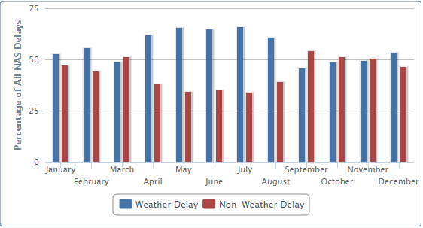
Figure 2. Weather's Share of National Aviation System (NAS) Delays National (January - December, 2019)
Delays or cancellations coded "NAS" are the type of weather delays that could be reduced with corrective action by the airports or the Federal Aviation Administration. During 2019, 56.8% of NAS delays were due to weather. NAS delays were 24.0% of total delays in 2019 ^{[6]}.

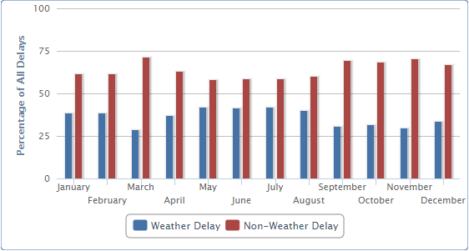
Figure 3. Weather's Share of Delayed Flights National (January - December, 2019)
Weather delay in the figure above is the sum of Extreme Weather delays, NAS delays caused by the weather as assigned by the FAA, and the Weather's pro-rata share of late-arriving-aircraft delays based on delay minutes. According to the BTS, the weather's share of delay as percent of total delay-minutes adds up to 38.7% in 2019 ^{[6]}.

Once weather contribution to delays has been broken down into manageable pieces and properly explained, it is evident that the model is going to be strongly affected by adverse meteorological conditions.

1.1 Subsection heading
Suspendisse dapibus lorem pellentesque magna. Integer nulla. Donec blandit feugiat ligula. Donec hendrerit, felis et imperdiet euismod, purus ipsum pretium metus, in lacinia nulla nisl eget sapien. Donec ut est in lectus consequat consequat. Etiam eget dui. Aliquam erat volutpat. Sed at lorem in nunc porta tristique.
Proin nec augue. Quisque aliquam tempor magna. Pellentesque habitant morbi tristique senectus et netus et malesuada fames ac turpis egestas. Nunc ac magna. Maecenas odio dolor, vulputate vel, auctor ac, accumsan id, felis. Pellentesque cursus sagittis felis. Pellentesque porttitor, velit lacinia egestas auctor, diam eros tempus arcu, nec vulputate augue magna vel risus. Cras non magna vel ante adipiscing rhoncus.
Vivamus a mi. Morbi neque. Aliquam erat volutpat. Integer ultrices lobortis eros. Pellentesque habitant morbi tristique senectus et netus et malesuada fames ac turpis egestas. Proin semper, ante vitae sollicitudin posuere, metus quam iaculis nibh, vitae scelerisque nunc massa eget pede. Sed velit urna, interdum vel, ultricies vel, faucibus at, quam. Donec elit est, consectetuer eget, consequat quis, tempus quis, wisi.
1.1.1 Subsubsection heading. In in nunc. Class aptent taciti sociosqu ad litora torquent per conubia nostra, per inceptos hymenaeos. Donec ullamcorper fringilla eros. Fusce in sapien eu purus dapibus commodo. Cum sociis natoque penatibus et magnis dis parturient montes, nascetur ridiculus mus. Cras faucibus condimentum odio. Sed ac ligula. Aliquam at eros.
Etiam at ligula et tellus ullamcorper ultrices. In fermentum, lorem non cursus porttitor, diam urna accumsan lacus, sed interdum wisi nibh nec nisl. Ut tincidunt volutpat urna. Mauris eleifend nulla eget mauris. Sed cursus quam id felis. Curabitur posuere quam vel nibh. Cras dapibus dapibus nisl. Vestibulum quis dolor a felis congue vehicula. Maecenas pede purus, tristique ac, tempus eget, egestas quis, mauris. Curabitur non eros. Nullam hendrerit bibendum justo. Fusce iaculis, est quis lacinia pretium, pede metus molestie lacus, at gravida wisi ante at libero. Quisque ornare placerat risus. Ut molestie magna at mi. Integer aliquet mauris et nibh. Ut mattis ligula posuere velit.
Nunc sagittis. Curabitur varius fringilla nisl. Duis pretium mi euismod erat. Maecenas id augue. Nam vulputate. Duis a quam non neque lobortis malesuada. Praesent euismod. Donec nulla augue, venenatis scelerisque, dapibus a, consequat at, leo.
Pellentesque libero lectus, tristique ac, consectetuer sit amet, imperdiet ut, justo. Sed aliquam odio vitae tortor. Proin hendrerit tempus arcu. In hac habitasse platea dictumst. Suspendisse potenti. Vivamus vitae massa adipiscing est lacinia sodales. Donec metus massa, mollis vel, tempus placerat, vestibulum condimentum, ligula. Nunc lacus metus, posuere eget, lacinia eu, varius quis, libero.
Aliquam nonummy adipiscing augue. Lorem ipsum dolor sit amet, consectetuer adipiscing elit. Maecenas porttitor congue massa. Fusce posuere, magna sed pulvinar ultricies, purus lectus malesuada libero, sit amet commodo magna eros quis urna. Nunc viverra imperdiet enim. Fusce est. Vivamus a tellus. Pellentesque habitant morbi tristique senectus et netus et malesuada fames ac turpis egestas.
Acknowledgements
Proin pharetra nonummy pede. Mauris et orci. Aenean nec lorem. In porttitor. Donec laoreet nonummy augue. Suspendisse dui purus, scelerisque at, vulputate vitae, pretium mattis, nunc. Mauris eget neque at sem venenatis eleifend. Ut nonummy.
References
- Michael Lukacs, FAA - APO-100 Deputy Division Manager, [2019], Cost of Delay Estimates
- On-Time Performance (OTP) [2019], US Bureau of Transportation Statistics
- Local Climatological Data (LCD) [2019], US National Oceanic and Atmospheric Administration
- Airline Service Quality Performance 234, [2019], US Bureau of Transportation Statistics
- Airline On-Time Performance and Causes of Flight Delays, [March 5, 2020], US Bureau of Transportation Statistics
- Understanding the Reporting of Causes of Flight Delays and Cancellations, [March 5, 2020], US Bureau of Transportation Statistics

